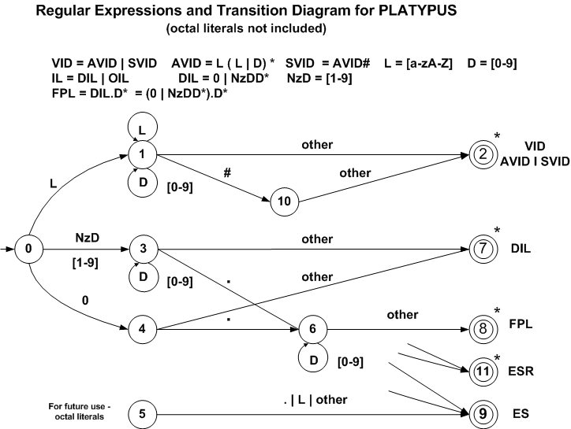

Transition Table
Current  State | INPUT SYMBOL |  |  |  |  |  | State Type  (Not Accepting or Accepting State)
Current  State | [a-zA-z] | 0 | [1-9] | . | # | other | State Type  (Not Accepting or Accepting State)
0 | 1 | 4 | 3 | IS  (ES) | IS  (ES) | IS  (ES) | Not Accepting - NOAS
1 | 1 | 1 | 1 | E/A | 10 | 2 | Not Accepting - NOAS
2 | IS | IS | IS | IS | IS | IS | VID - Accept With Retract - ASWR
3 | E/A | 3 | 3 | 6 | 7 | 7 | Not Accepting - NOAS
4 | E/A | E/A | E/A | 6 | 7 | 7 | Not Accepting - NOAS
5 | ES |  |  | ES | ES | ES | Not Accepting - NOAS
6 | E/A | 6 | 6 | E/A | 8 | 8 | Not Accepting - NOAS
7 | IS | IS | IS | IS | IS | IS | DIL - Accept With Retract - ASWR
8 | IS | IS | IS | IS | IS | IS | FPL - Accept With Retract - ASWR
9 | IS | IS | IS | IS | IS | IS | ES - Accept No Retract - ASNR
10 | ES | ES | ES | ES | ES | 2 | Not Accepting – NOAS
11 | IS | IS | IS | IS | IS | IS | ESR - Accept With Retract - ASWR

IS – Illegal State ES – Error State E/A – Error state or Accepting state

